

PRESENTS Ameri Americas

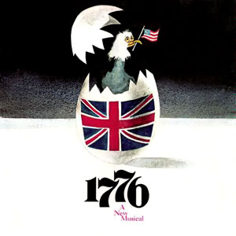

Music and Lyrics by

Sherman Edwards

Book by

Peter Stone

**TICKETS:**

**Opening Night special**

**Thursday, June 13th**

**All seats ONLY $18**

**Friday, Saturday, Sunday:**

**Adults: $22**

**Seniors 65+ and children 14 and under: $20**

**Prairie Lakes Theatre**

515 E. Thacker Street

Des Plaines, IL 60016

Call 773-736-2490 or email

[risingstarstc@gmail.com](mailto:risingstarstc@gmail.com) for more information

www.risingstarschicago.com

***Celebrate the birth of a new nation—America!***

**THURSDAY, FRIDAY, SATURDAY, and SUNDAY**

**June 13, 14, 15 (2 shows), 16, 2024**

**Thursday/Friday/Saturday 7:30 PM; Saturday/Sunday 2:00 PM**

Based on a concept by

Sherman Edwards

Original Production Directed by Peter Stone