

PRESENTS Ameri Americas

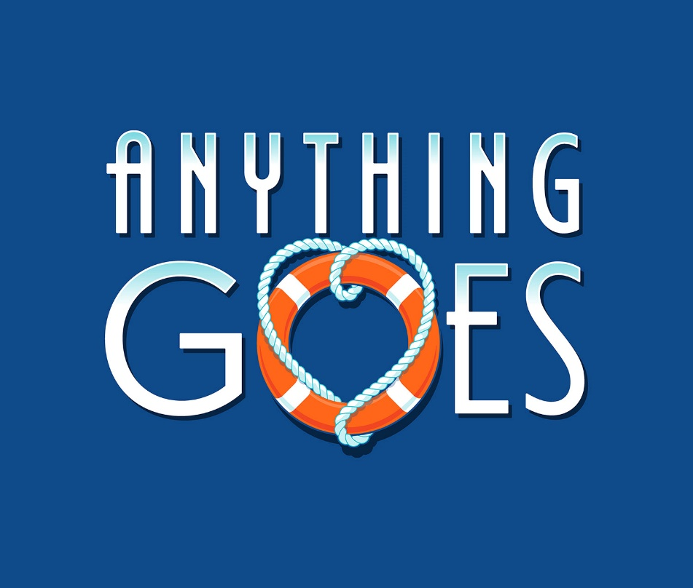

**Music and Lyrics by:**

Cole Porter

**Book by:**

Guy Bolton, P.G. Wodehouse, Howard Lindsay and Russell Crouse

**TICKETS:**

IN ADVANCE (thru 10/19/2019):

ADULTS $20; SENIORS/CHILDREN $18

10/19/2019 and after:

ADULTS $22; SENIORS/CHILDREN $20

WWW.RISINGSTARSCHICAGO.COM

OR CALL (773) 736-2490 FOR MORE INFO

**FRIDAY, SATURDAYS, AND SUNDAYS**

**November 2, 3, 8, 9, 10, 2019**

**FRIDAY/SATURDAYS 7:30 PM; SUNDAYS 2:00 PM**

**WEST LEYDEN HS AUDITORIUM Entrance #2**

1000 N. WOLF RD., NORTHLAKE

(2 BLOCKS SOUTH OF GRAND AVE.)