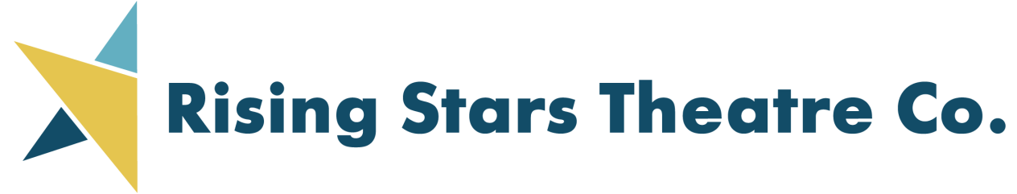

PRESENTS Ameri Americas



**WEST LEYDEN HS AUDITORIUM Entrance #2**

1000 N. WOLF RD., NORTHLAKE

(2 BLOCKS SOUTH OF GRAND AVE.)

Call 773-736-2490 or email

[risingstarstc@gmail.com](mailto:risingstarstc@gmail.com) for more information

77

Presented by arrangement with The Musical Company, a Concord Theatricals Company

**TICKETS:**

IN ADVANCE (thru 10/18/21):

ADULTS $20; SENIORS/CHILDREN $18

10/19/21 and after:

ADULTS $22; SENIORS/CHILDREN $20

Order on-line at:

[**WWW.RISINGSTARSCHICAGO.COM**](http://WWW.RISINGSTARSCHICAGO.COM)

**FRIDAY, SATURDAYS, AND SUNDAYS**

**Nov. 5, 6, 7, 12, 13, 14, 2021**

**FRIDAY/SATURDAYS 7:30 PM; SUNDAYS 2:00 PM**