

PRESENTS Ameri Americas

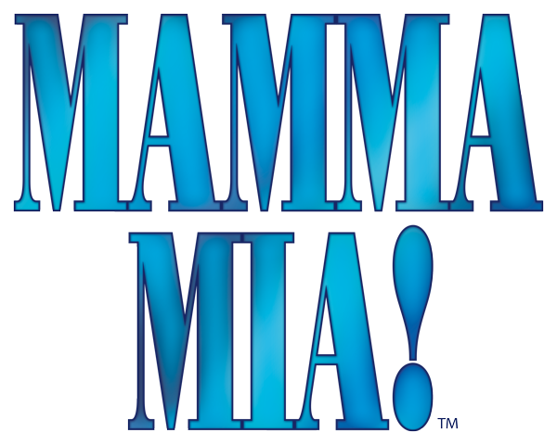

**Music and Lyrics by:**

Benny Andersson

Bjorn Ulvaeus

And some songs with

Stig Anderson

**Book by:**

Catherine Johnson

**TICKETS:**

IN ADVANCE (thru 6/8/2019):

ADULTS $18; SENIORS/CHILDREN $16

6/9/2019 and after:

ADULTS $20; SENIORS/CHILDREN $18

WWW.RISINGSTARSCHICAGO.COM

OR CALL (773) 736-2490 FOR MORE INFO

**FRIDAY, SATURDAYS, AND SUNDAYS**

**June 22, 23, 28, 29, 30, 2019**

**FRIDAY/SATURDAYS 7:30 PM; SUNDAYS 2:00 PM**

**WEST LEYDEN HS AUDITORIUM Entrance #2**

1000 N. WOLF RD., NORTHLAKE

(2 BLOCKS SOUTH OF GRAND AVE.)