presents

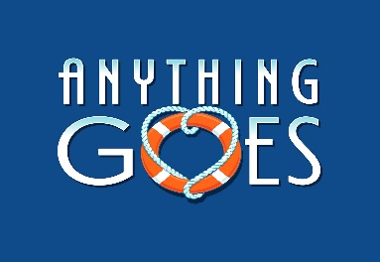

Music, Dance, Laughs, and the age old tale of boy meets girl… ANYTHING GOES is a hilarious shipboard romp wrapped around one of Cole Porter’s most magical scores. It’s Deligtful, Delicious and De-Lovely with night club singers, gangsters, lovers and more!
At West Leyden HS Auditorium,
1000 N. Wolf Rd., Entrance #2, Northlake, IL
(2 blocks south of Grand Ave.)
7:30 PM Friday & Saturdays; 2:00 PM Sundays
Saturday, Nov. 2  Sunday, Nov. 3 | Friday, Nov. 8  Saturday, Nov. 9  Sunday, Nov. 10

Ticket Order Form
Show Date(s) | # Adult  $20 thru 10/19  $22 after 10/19 | # Senior (65+)/ Children (2-14)  $18 thru 10/19  $20 after 10/19 | # Group Rate  (20 or more)  $2 off per ticket |  | Check if Wheelchair Seating Required
 |  |  |  |  | How many? ______
TOTAL AMOUNT $ Note: tickets are $22 (Adult) and $20 (Children/Seniors) after 10/19

Select Payment Method: Credit Card (fill out info below) Check: (number )
Make checks payable to the Rising Stars Theatre Company

Credit Card | Visa MC CC# Exp Date:
Info | CVV Code: (3-digit number on back of card): Cardholder Name:

Name
Address
City |  | State |  | Zip
Eve. Phone |  | E-mail

Select Receipt Method: | MAIL THIS FORM WITH PAYMENT OR CC INFO ENCLOSED TO:  The Rising Stars Theatre Company  P.O. Box 232, Franklin Park, IL 60131
Mail (enclose stamped, addressed envelope)
Will Call under (name)
Email to (address)

ORDER TICKETS ONLINE! Visit our website at www.risingstarschicago.com and click Tickets
Online orders are payable by credit card only.
For more ticket information visit our website, call (773) 736-2490, or e-mail risingstarstc@gmail.com

