presents

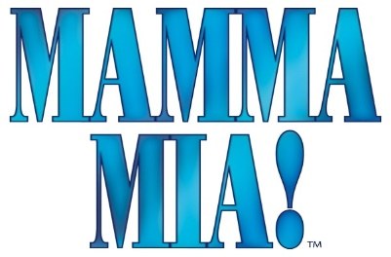

ABBA’s hits tell the hilarious story of a young woman’s search for her birth father. This sunny and funy tale unfolds on a Greek Island paradise. On the eve of her wedding, a daughter’s quest to discover the identity of her father brings three men from her mother’s past back to the island they last visited 20 years ago.
At West Leyden HS Auditorium,
1000 N. Wolf Rd., Entrance #2, Northlake, IL
(2 blocks south of Grand Ave.)
7:30 PM Friday & Saturdays; 2:00 PM Sundays
Saturday, June 22  Sunday, June 23 | Friday, June 28  Saturday, June 29  Sunday, June 30

Ticket Order Form
Show Date(s) | # Adult  $18 thru 6/8  $20 after 6/8 | # Senior (65+)/ Children (2-14)  $16 thru 6/8  $18 after 6/8 | # Group Rate  (20 or more)  $2 off per ticket |  | Check if Wheelchair Seating Required
 |  |  |  |  | How many? ______
TOTAL AMOUNT $ Note: tickets are $20 (Adult) and $18 (Children/Seniors) after 6/8

Select Payment Method: Credit Card (fill out info below) Check: (number )
Make checks payable to the Rising Stars Theatre Company

Credit Card | Visa MC CC# Exp Date:
Info | CVV Code: (3-digit number on back of card): Cardholder Name:

Name
Address
City |  | State |  | Zip
Eve. Phone |  | E-mail

Select Receipt Method: | MAIL THIS FORM WITH PAYMENT OR CC INFO ENCLOSED TO:  The Rising Stars Theatre Company  P.O. Box 232, Franklin Park, IL 60131
Mail (enclose stamped, addressed envelope)
Will Call under (name)
Email to (address)

ORDER TICKETS ONLINE! Visit our website at www.risingstarschicago.com and click Tickets
Online orders are payable by credit card only.
For more ticket information visit our website, or call (773) 736-2490, or e-mail risingstarsorders@ameritech.net

