presents
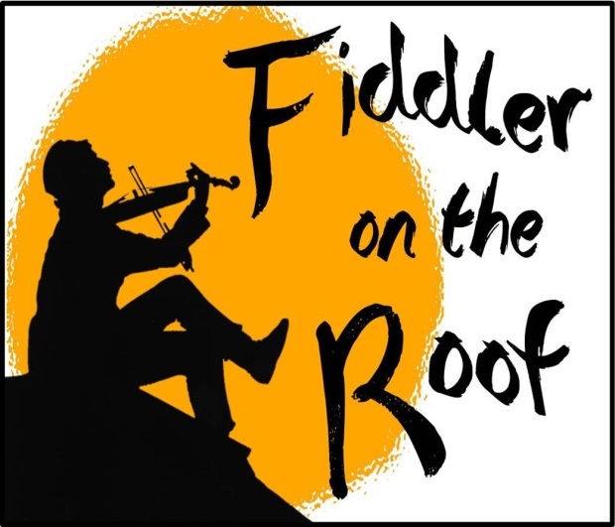
This beloved musical tradition has been charming theatre-goers the world over for more than 50 years. The story of Tevye the milkman still has the power to touch audiences with its vivid characters, warmth, honesty, and humor. Rich in historic and ethnic detail, all can relate to its universal themes of tradition.
 | 7:30 PM Fridays & Saturdays; 2:00 PM Sundays
Produced on the New York Stage by Harold Prince  Original New York Stage Production Directed and Choreographed by Jerome Robbins  Book by: Joseph Stein  Music by: Jerry Bock  Lyrics by: Sheldon Harnick  Based on Sholem Aleichem stories  by special permission of Arnold Perl | Fri., June 24  Sat., June 25  Sun., June 26 | Fri., July 1  Sat., July 2  Sun., July 3
At East Leyden HS Auditorium
3400 Rose St., Franklin Park, IL
(Entrance #21 on King Blvd.)

Ticket Order Form
Show Date(s) | # Adult  @ $18 | # Senior (60+)/ Children (2-14)  @ $16 | # Group Rate  (20 or more)  $2 off per ticket |  | Check if Wheelchair Seating Required
 |  |  |  |  | How many? ______
TOTAL AMOUNT $ Note: Same day door sale tickets are $20 (Adult) and $18 (Children/Seniors)

Select Payment Method: Credit Card (fill out info below) Check: (number )
Make checks payable to the Rising Stars Theatre Company

Credit Card | Visa MC CC# Exp Date:
Info | CVV Code: (3-digit number on back of card): Cardholder Name:

Name
Address
City |  | State |  | Zip
Eve. Phone |  | E-mail

Select Receipt Method: | MAIL THIS FORM WITH PAYMENT OR CC INFO ENCLOSED TO:  The Rising Stars Theatre Company  P.O. Box 232, Franklin Park, IL 60131
Mail (enclose stamped, addressed envelope)
Will Call under (name)

ORDER TICKETS ONLINE! Visit our website at www.risingstarschicago.com and click Tickets
Online orders are payable by credit card only.
For more ticket information visit our website, or call (773) 736-2490, or e-mail risingstarsorders@ameritech.net
If you want to be removed from our mailing list, e-mail info@risingstarschicago.com or call the phone number above.

The Rising Stars Theatre Company
P.O. Box 232
Franklin Park, IL 60131

East Leyden HS Auditorium
3400 Rose St., Franklin Park (Entrance #21 on King Blvd.)
- Ample free parking!
- NO STAIRS—WALK RIGHT IN AND SIT RIGHT DOWN!!!
- Fully handicapped-accessible
- Order tickets by mail or online at www.risingstarschicago.com
Fiddler on the Roof
June 24–July 3, 2016

