presents
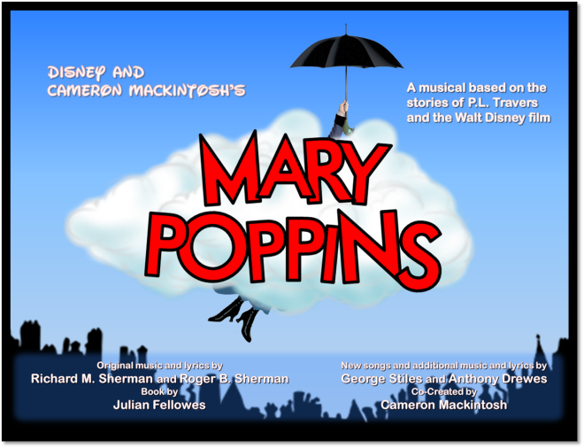
One of the most popular Disney movies of all time is capturing hearts in a whole new way: as a practically perfect musical! Based on the books by P.L. Travers and the classic 1964 Disney film, Mary Poppins delighted Broadway audiences for over 2,500 performances and received nominations for seven TONY Awards, including Best Musical.
 | 7:30 PM Fridays & Saturdays; 2:00 PM Sundays
 | Fri., June 19  Sat., June 20  Sun., June 21 | Fri., June 26  Sat., June 27  Sun., June 28
At The Cuny Auditorium at Guerin Prep,
8001 W. Belmont Ave., River Grove
(3 blocks east of Cumberland Ave.)

Ticket Order Form
Show Date(s) | # Adult  @ $18 | # Senior (60+)/ Children (2-14)  @ $16 | # Group Rate  (20 or more)  $2 off per ticket |  | Check if Wheelchair Seating Required
 |  |  |  |  | How many? ______
TOTAL AMOUNT $ Note: Same day door sale tickets are $20 (Adult) and $18 (Children/Seniors)

Select Payment Method: Credit Card (fill out info below) Check: (number )
Make checks payable to the Rising Stars Theatre Company

Credit Card | Visa MC CC# Exp Date:
Info | CVV Code: (3-digit number on back of card): Cardholder Name:

Name
Address
City |  | State |  | Zip
Eve. Phone |  | E-mail

Select Receipt Method: | MAIL THIS FORM WITH PAYMENT OR CC INFO ENCLOSED TO:  The Rising Stars Theatre Company  P.O. Box 34197, Chicago, IL 60634
Mail (enclose stamped, addressed envelope)
Will Call under (name)

ORDER TICKETS ONLINE! Visit our website at www.risingstarschicago.com and click Tickets
Online orders are payable by credit card only.
For more information visit our website, or call (773) 736-2490, or e-mail risingstarsorders@ameritech.net

