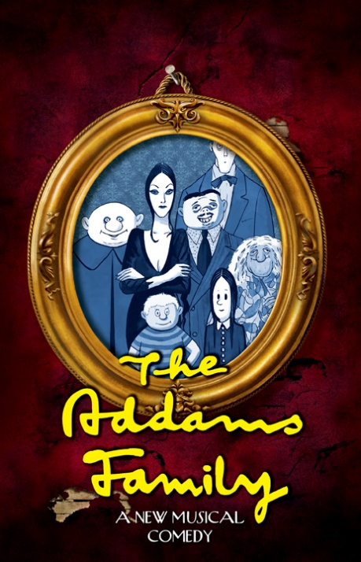
presents
This new Broadway musical comedy is adapted from the 1964 TV series, based on the characters of New Yorker cartoonist Charles Addams. The musical features an original story, and it’s every father’s nightmare. Wednesday Addams, the ultimate princess of darkness, has grown up and fallen in love with a sweet, smart young man from a respectable family. Everything will change for the whole family on the fateful night the Addamses host a dinner for Wednesday’s “normal” boyfriend and his parents.
 | 7:30 PM Fridays & Saturdays; 2:00 PM Sundays
 | Fri., October 6  Sat., October 7  Sun., October 8 | Fri., October 13  Sat., October 14  Sun., October 15
West Leyden HS Auditorium-Main Entrance #2
1000 N. Wolf Rd., Northlake, IL. 60164
(2 block south of Grand Ave.)

Ticket Order Form
Show Date(s) | # Adult  @ $18 | # Senior (60+)/ Children (2-14)  @ $16 | # Group Rate  (20 or more)  $2 off per ticket |  | Check if Wheelchair Seating Required
 |  |  |  |  | How many? ______
TOTAL AMOUNT $ Note: Same day door sale tickets are $20 (Adult) and $18 (Children/Seniors)

Select Payment Method: Credit Card (fill out info below) Check: (number )
Make checks payable to the Rising Stars Theatre Company

Credit Card | Visa MC CC# Exp Date:
Info | CVV Code: (3-digit number on back of card): Cardholder Name:

Name
Address
City |  | State |  | Zip
Eve. Phone |  | E-mail

Select Receipt Method: | MAIL THIS FORM WITH PAYMENT OR CC INFO ENCLOSED TO:  The Rising Stars Theatre Company  P.O. Box 232, Franklin Park, IL 60131
Mail (enclose stamped, addressed envelope)
Will Call under (name)
E-mail (please include e-mail)_________________

ORDER TICKETS ONLINE! Visit our website at www.risingstarschicago.com and click Tickets
Online orders are payable by credit card only.
For more ticket information visit our website, or call (773) 736-2490, or e-mail risingstarsorders@ameritech.net

