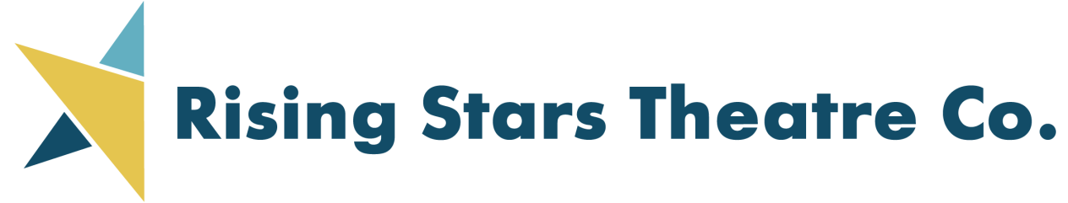

PRESENTS Ameri Americas

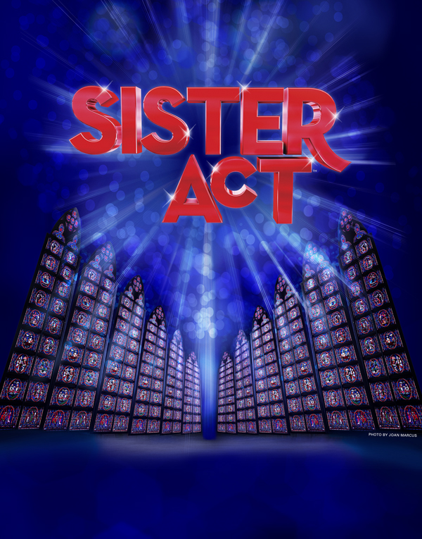

Music By Alen Menkin

Lyrics by Glenn Stater

**WEST LEYDEN HS AUDITORIUM Entrance #2**

1000 N. WOLF RD., NORTHLAKE

(2 BLOCKS SOUTH OF GRAND AVE.)

Call 773-736-2490 or email

[risingstarstc@gmail.com](mailto:risingstarstc@gmail.com) for more information

77

Book by Cheri Steinkellner & Bill Steinkellner

**TICKETS:**

IN ADVANCE (thru 6/1/2022):

ADULTS $20; SENIORS/CHILDREN $18

6/2/2022 and after:

ADULTS $22; SENIORS/CHILDREN $20

Order on-line at:

[**WWW.RISINGSTARSCHICAGO.COM**](http://WWW.RISINGSTARSCHICAGO.COM)

**Face Masks required**

**FRIDAY, SATURDAYS, AND SUNDAYS**

**June 11, 12, 17, 18, 19, 2022**

**FRIDAY/SATURDAYS 7:30 PM; SUNDAYS 2:00 PM**