

PRESENTS Ameri Americas

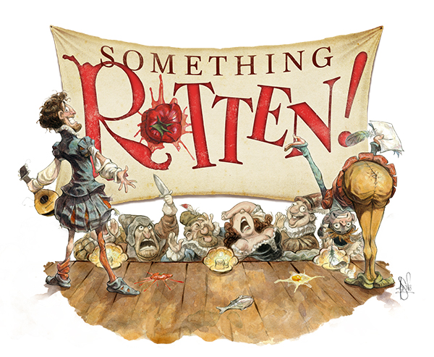

Music By

Wayne Kirkpatrick & Karey Kirkpatrick

**Prairie Lakes Theatre**

515 E. Thacker Street

Des Plaines, IL 60016

Call 773-736-2490 or email

[risingstarstc@gmail.com](mailto:risingstarstc@gmail.com) for more information

www.risingstarschicago.com

**TICKETS:**

**Opening Night special**

**Thursday, Nov 3rd**

**All seats ONLY $15**

**Friday, Saturday, Sunday:**

**Adults: $22**

**Seniors 65+ and children 14 and under: $20**

**Face Masks optional**

Book by

Karey Kirkpatrick &

John O’Farrell

**THURSDAY, FRIDAY, SATURDAY, and SUNDAY**

**Nov. 3, 4, 5 (2 shows), 6 2022**

**Thursday/Friday/Saturday 7:30 PM; Saturday/Sunday 2:00 PM**