presents
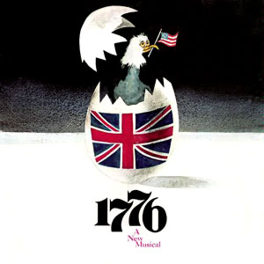
Witness the birth of a new nation as our forefathers struggle to craft the Declaration of Independence! It’s the summer of 1776 and the nation is ready to declare independence from the British Monarchy-if only the founding fathers can agree! 1776 is a funny, Insightful and compelling drama with a striking score and a legendary book.

Prairie Lakes Theatre
515 E. Thacker St. Des Plaines, Il 60016
7:30 PM Thursday, Friday & Saturday
2:00 PM Saturday and Sunday
Thurs. June 13  Sat. June 15 (2:00 pm) | Fri. June 14  Sat. June 15 (7:30 pm)  Sun. June 16
Opening night special: Thursday June 13-all seats only $18.00!!!

Ticket Order Form
Show Date(s) | # Adult  June 14. 15, 16  $22 | # Senior (65+)/ Children (2-14)  June 14, 15. 16  $20 | # June 13 only  $18 all seats |  | Check if Wheelchair Seating Required
 |  |  |  |  | How many? ______
TOTAL AMOUNT $ Group rates available: call 773-736-2490

Select Payment Method: Credit Card (fill out info below) Check: (number )
Make checks payable to the Rising Stars Theatre Company

Credit Card | Visa MC CC# Exp Date:
Info | CVV Code: (3-digit number on back of card): Cardholder Name:

Name
Address
City |  | State |  | Zip
Phone |  | E-mail

Select Receipt Method: | MAIL THIS FORM WITH PAYMENT OR CC INFO ENCLOSED TO:  The Rising Stars Theatre Company  P.O. Box 232, Franklin Park, IL 60131
Mail (enclose stamped, addressed envelope)
Will Call under (name)
Email to (address)

ORDER TICKETS ONLINE! Visit our website at www.risingstarschicago.com.
Online orders are payable by credit card only. For information call 773-736-2490 or email: risingstarstc@gmail.com

