presents

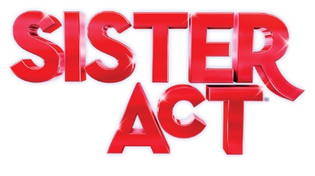
This feel-good comedy smash is based on the hit 1992 film. After witnessing a murder, a woman hiding in a convent helps her fellow sisters find their voices as she rediscovers her own. Filled with powerful gospel music, outrageous dancing and a truly moving story, Sister Act will leave you breathless. A Sparkling tribute to the universal power of friendship. Sister Act is a reason to rejoice
At West Leyden HS Auditorium,
1000 N. Wolf Rd., Entrance #2, Northlake, IL
(2 blocks south of Grand Ave.)
7:30 PM Friday & Saturdays; 2:00 PM Sundays
Saturday, June 11  Sunday, June 12 | Friday, June 17  Saturday, June 18  Sunday, June 19

Ticket Order Form
Show Date(s) | # Adult  $20 thru 6/1  $22 after 6/1 | # Senior (65+)/ Children (2-14)  $18 thru 6/1  $20 after 6/1 | # Group Rate  (20 or more)  $2 off per ticket |  | Check if Wheelchair Seating Required
 |  |  |  |  | How many? ______
TOTAL AMOUNT $

Select Payment Method: Credit Card (fill out info below) Check: (number )
Make checks payable to the Rising Stars Theatre Company

Credit Card | Visa MC CC# Exp Date:
Info | CVV Code: (3-digit number on back of card): Cardholder Name:

Name
Address
City |  | State |  | Zip
Eve. Phone |  | E-mail

Select Receipt Method: | MAIL THIS FORM WITH PAYMENT OR CC INFO ENCLOSED TO:  The Rising Stars Theatre Company  P.O. Box 232, Franklin Park, IL 60131
Mail (enclose stamped, addressed envelope)
Will Call under (name)
Email to (address)

ORDER TICKETS ONLINE! Visit our website at www.risingstarschicago.com and click Tickets
Online orders are payable by credit card only.
For more ticket information visit our website, call (773) 736-2490, or e-mail risingstarstc@gmail.com

